[eHealth: TSA, TSC – V1 & V2]
[SIC: Tom Van den heuvel, eHealth: …]

Tests Informations

Goals
A performance test is requested (François Van Hees, Felix Fraters) using updated usage estimates and with special attention to the use of the archiving option for TSA.
Performance testing types
Reference, load, stress + determination of maximum achievable throughput and identification of the current bottleneck

Scenarii [coach sic]
Name | Short description / goals | #users/day | #executed scenario /year | Pick/max? | Link to scenario(SoapUI, Selenium, Jmeter, screenshot…) with dataset (xls, sql query,…)
TSA V1: stamp document (profile 1.0) SignRequest with archival | Stamp a document with archival (v1) |  |  |  | tsa_v1_profile_10
TSA V1: stamp hash (profile 2.0) SignRequest with archival | Stamp a hash with archival (v1) |  |  |  | tsa_v1_profile_20
TSA V1: stamp document SignRequest w/o archival (profile 1.0) | Stamp a document w/o archival (v1) |  |  |  | tsa_v1_profile_10
TSA V1: stamp hash SignRequest w/o archival (profile 2.0) | Stamp a hash w/o archival (v1) |  |  |  | tsa_v1_profile_20
TSA V2: stamp document SignRequest with archival (profile 1.1) | Stamp a document with archival (v2) |  |  |  | tsa_v2_profile_11
TSA V2: stamp hash SignRequest with archival (profile 2.1) | Stamp a hash with archival (v2) |  |  |  | tsa_v2_profile_21
TSA V2: stamp document SignRequest w/o archival (profile 1.1) | Stamp a document w/o archival (v2) |  |  |  | tsa_v2_profile_11
TSA V2: stamp hash SignRequest w/o archival (profile 2.1) | Stamp a hash w/o archival (v2) |  |  |  | tsa_v2_profile_21
TSC V1: TSConsultTSBagRequest | Get a list of timestamp token (v1) |  |  |  | tsc_v1_TSConsultTSBagRequest
TSC V1: TSConsultRequest (verifyStatus) | Verify the status of timestamp (arg) compared to distant db state (v1) |  |  |  | tsc_v1_TSConsultRequest
TSC V2: TSConsultTSBagRequest | Get a list of timestamp token (v2) |  |  |  | tsc_v2_TSConsultTSBagRequest
TSC V2: TSConsultRequest (verifyStatus) | Verify the status of timestamp (arg) compared to distant db state (v2) |  |  |  | tsc_v2_TSConsultRequest

Current volume:
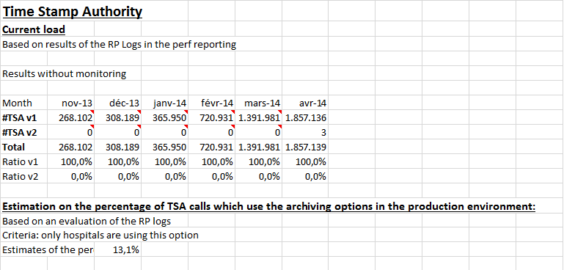
Expected Volume :

TSA V1 with archiving used by hospitals

Currently approximately 50% of the hospitals use TSAV1. A load test could be performed by extrapolating the numbers monitored for use by 100% of the hospitals.

TSA V2 without archiving, data related to “DPP” and “Recip-e” usage
- DPP => 1 million requests per day
- Recip-e => 65 timestamps per second. Once in full production we need to take in account peaks of 100 timestamps/sec
dixit Kris Van Aken : Recip-e parameters als in regime (doelgroep arts - apotheker):
- 100 miljoen voorschriften per jaar;
- 65 requests (createPrescription) per seconde (65 timestamp calls per seconde)
Als Recip-e op volle toeren draait moet men rekening houden met pieken tot 100 createPrescription requests (timestamp calls) per seconde.
Op dit moment wordt V2 nog niet echt gebruikt, maar volgens Guy moet deze met dezelfde volumes als V1 getest worden.

Database
A dump of production
Actual and expected volume: TODO
Actual volume :

Project Informations

Spocs
CSM: | CPT:
CP: Michel Stuckens | Architect: Benoit Dupont
Analyst: Luca Di Marino

Project planning
Sic tests: purple phase (6/2014) or the blue phase that follows
I don’t see any purple phase in june, do you mean july or I miss something ?

Business description
[Project goals & short business description]
The Timestamping service allows to hospitals putting a timestamp on their data ( medical prescription for example) with the aim of proving the existence of these data on a given date and hour. Moreover the service allows the production, the issuance and the conservation of elements which can certify the timestamping of a document (request asked by the hospital, response token sent to the hospital, time returned by the timestamp authority, client name, document, document type, …).
The service is composed by:
- A web service which links a timestamp to documents and store these documents with the elements proving the timestamp creation in a database (TimeStamp Authority)
- A web service which allows consulting the stamped stored documents (TimeStamp Consult)
In addition of the hospitals, the NIHDI has also access to the stamped stored document as supervisory institution.
Application URI:
tsa.1.endpoint=https://wwwpx.ehealth.fgov.be/timestampauthority_1_5/timestampauthority
tsc.1.endpoint=https://wwwpx.ehealth.fgov.be/timestampconsult_1_3/timestampconsult
tsa.2.endpoint=https://servicespx.ehealth.fgov.be/TimestampAuthority/v2
tsc.2.endpoint=https://servicespx.ehealth.fgov.be/TimestampConsult/v2
Where x is either “1” or “2” to point to the current acceptation environment
- To ask Middleware team
Archives
Name | Version | First prod.? | Goals | Svn link
authority | 20141 | [no] |  | http://svn15.smals-mvm.be/svn/timestamping/branches/timestamping_Branch_20141/authority/
consult | 20141 |  |  | http://svn15.smals-mvm.be/svn/timestamping/branches/timestamping_Branch_20141/consult/
Released archives on http://albanil15.smals-mvm.be/repo/release/be/fgov/ehealth/timestamping
Note that this is 20141, no branch has been created for 20142

Architecture
SAD’s:
TSA: http://intranet.smals.be/mayanl/livelink/2386775/SAD_Behealth_TTSA_-_v2.doc?func=doc.Fetch&nodeid=2386775&newtarget=true
TSC: http://intranet.smals.be/mayanl/livelink/2251418/SAD_Behealth_TTSC_-_v1.doc?func=doc.Fetch&nodeid=2251418&newtarget=true

External components used :
Component name | Methods used | version | Mocked ? | Read/Write | #request/scenario | DB information (dump?, datasource)
Ncipher server |  |  | No

Security specification:
[Short description of the security used by the application : transport, authentication, UAM, X509…]
The webservice is secured using X509 and accessible via https.
Infrastructure

[Production deployment diagram : servers, components(ear, war…),DB…]
See images attachements or SAD’s
[Describe differences and particularities between production and test environment : clustering, middleware version, load db, mock]
The application will be tested in the acceptation environment.
Response from Jo Van Hoof:
Physical machines OVM are different between accept (here bugfix) and production: production is dedicated to ehealth core, bugfix is shared with vas, integration and test. At virtual machine level, no differences. At database level, no difference, except currently (temporary) accept runs in two nodes instead of 3). Version is the same, clustering is the same. There’s one ncipher server in acceptation, and two with load balancing in production.
SLA
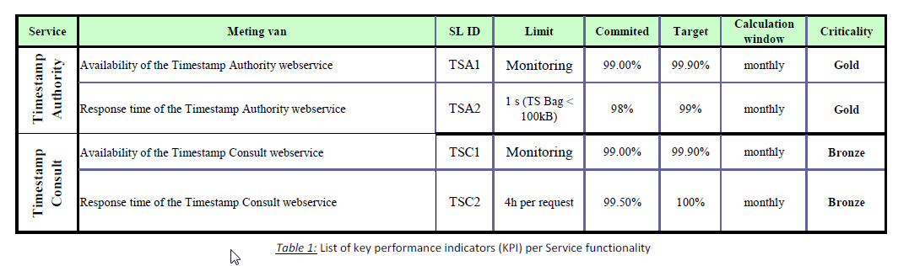
See attachment for more details

Customer:
Entity x1: archiving activated TODO: provide ehealth the certificate
Entity x2: archiving de-activated TODO: provide ehealth the certificate
Action points:
- Sic will provide both certificates to ehealth (can you do that or you need us to provide them ?)
- Ehealth will configure both entities and parameters configuration in acceptance (when ?))
- François Van Hees team will provide by service current and foreseen service usage figures

Package shared on \\smals-mvm.be\data\600\630\642\sic\archives

Archives
Sql creation script
Database dump

